**Detecting the Emotions from Handwriting Recognition Using Natural Language Processing**

**Somtirtha Mukherjee, Rahil Mohammad, Indranil Ray, Dr. Sharmila Banu K**

*School of Computer Science and Engineering (SCOPE), VIT University, Vellore*

**ABSTRACT:**

Human beings are a social species and what makes us different than machines apart from our natural intelligence is that we consist of sentiments and certain emotional quotient. The motive of this paperwork is to reflect our work on the sentiment analysis of human beings, but in this work, we do that by merely taking our deep analytics into the depth of handwritten texts. Writing is one of the most fascinating aspect of representation of the process of communication among human beings. The emotion attached to a person gets reflected with the text that is being documented in a writing. Hence, handwritten texts are a perfect way to judge someone’s sentiment. Handwriting shows the true personality including behaviour, emotional outlay, self-esteem, anger, imagination, honesty, fears, defences, and many other personality traits. Applications of Handwriting analysis consist of a wide range in the various fields such as psychology, medical diagnosis, recruitment of staff, career counselling, writer identification, forensics studies etc. This paper provides an outline of handwriting analysis, feature extraction of handwriting, its related personality traits, overview of the handwriting analysis system (HAS) and a literature survey of the existing papers on handwriting analysis.

**KEYWORDS:** *Handwriting Recognition, Sentiment Analysis*, *NLP, OpenCV, Tesseract, Classification, Image Processing.*

**I. INTRODUCTION:**

Over the years, literature has been the primal stem of the expressiveness of the human mind. People all around the globe use several languages and expressions to help with communication flow to grow as a society, as a nature’s being. The literature ultimately captures a certain point of emotional high-lows of the human mind. A human mind can easily decipher what emotional messages are encoded within some para-jumbles of letters and words, but the very thing seemed nearly impossible for a machine as many researchers believed that machines lack the emotional quotient present only in human beings. As it turns out, machines do lack the quality but certainly can overcome this with the advent of natural language processing. Several NLP toolkits nowadays help machines to learn or rather capture directly from hand-written texts. This was a revolutionary progress in the world of machine learning. The machines are now able to train themselves about detecting the texts from hand-written documents. Now, if they can detect letters, then they can be trained to detect words, then, from words they can be trained to detect sentences and so on. Hence, at this very point of time there are several social media platforms that can perform a varied number of natural language processing tasks ranging from auto-correction of words to next word prediction. In this work, we will try to analyse the sentiment attached to a text from learning the contents of the text. The machine automatically detects the handwritten texts and comes up with the simple classification of whether the text can be classified as containing positive or negative sentiment. This work consists of two main parts, first part is to train the model for the detection purpose of the handwritten texts while the next part is the determination of the sentiment from the test dataset which contains the handwritten texts. Hence, the first part is obviously a classical case of image processing while the second part is a classical NLP problem. The approach to this work is solely based on the dataset that we have used and cited the dataset in the Reference column of this document. We tried to accomplish this work using Optical Character Recognition (OCR), NLP toolkits and Naïve-Bayes Classifier and finally achieved an accuracy of 86%.

**II. LITERATURE SURVEY:**

Before starting our own work, we wanted to grasp a clear idea about the work that has already been done and tried to extract insights from them. Of course, we are working on two of the most exciting and promising areas of deep learning: image processing and natural language processing. When we first tried to get an idea of formulating our idea into a real-world project, we found quite astonishing works that already have been published. For instance, in [4], the authors have done sentiment analysis-based mining using Support Vector Machines.We draw inspirations and guidelines from [12] to learn about OCR in details. As the course of this literature progresses, the relevance and importance of OCR in our work will become more prominent. Apart from the derivation of knowledge about OCR from several papers such as [2] and [8], we also found the importance to bulk up our knowledge on Sentiment analysis. After all, the main objective of this work is to analyse the sentiment of the text from a handwritten document. For this purpose, we have gone through [7], [17] and [18] to invoke insights about the process.

**WORK-FLOW**

In computer science, algorithm plays a major role in deciding the output. But perhaps the most important aspect of an algorithm is that it leads to a neat and clean operation that can be understood and modified, if necessary, by any concerned. Algorithm is simply a term coined to suit the needs of computer scientists to represent the work flow a code. In Figure 1, we represent the workflow of this project. As per the workflow diagram, we take an input from the OCR and convert it to the raw text. Then this raw text is then noise removed and normalised to get processed for word standardisation using regular expression look up table. Then the classification is done using Naïve-Bayes classifier.

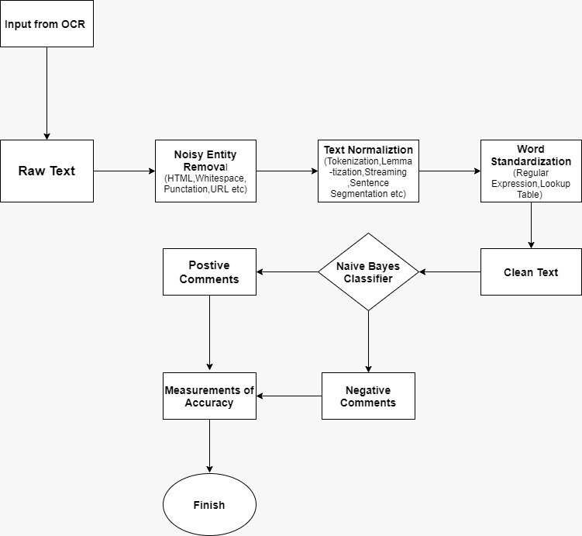

Figure 1: WorkFlow

**III.IMAGE PROCESSING:**

An interesting approach to life is to search for our roots and comparing how far have we come to relish the sweet taste of technology. There are questions that surround us about our ancestors and their lives. It is almost certain that men in this twenty first century are living far away from the realms of nature while the yesteryears of this world have seen our ancestors live in a perfect harmony with the nature, which was always meant to be. Developing an understanding about the lifestyle not only of ancient times but also of the people from around the globe even at our times, seems to be a daunting task. Nevertheless, human beings have always been thrived around challenges, from the first expressive sign languages of the cavemen to the well nurtured grammatical developments of a literature of today, the evolution has always supported Darwin and his theory of “Survival of the Fittest”. But it is not always about surviving, sometimes, we want more than just to survive. Here comes the aspect of finding our root and developing communications through ancient texts and even languages. If we consider about the process of human brain getting accustomed to a domain of recognition, be it a person or be it a language, we often find the numerous amount of sample made us accustomed to a certain things in and around our lives. The recognition of a person or the way of communications can be sub-divided into obvious parts of recognition of the image and audio.

Image Processing is one of the most fascinating fields of computer vision nowadays. In many of the texts there have been suggestions for several techniques for this process. However, in this work, we have taken a simple approach that consists of Optical character recognition using Tesseract Engines and pre-trained models such as EAST model. The process has been discussed in the sub-sections followed by this main section.

**IV. *OCR:***

OCR is abbreviation for Optical Character Recognition. It helps us to capture characters from images or texts. For human beings, the eyes work as the optical instrument that captures images or texts and it is the input to the brain. Now, the ability to understand these inputs varies in each person according to many factors [1]. OCR is a technology that functions like human ability of reading [2]. Basically, OCR enables us to convert several types of documents, such as jpg images or PDF files. In this work, we have used OCR to digitise our training dataset. Figure 1 below shows the OCR system block diagram.

Figure : Block Diagram of OCR [3]

**V. EAST Model:**

EAST stands for Efficient Accurate Scene Text detector, which is a very robust deep learning method for text detection. EAST can find both horizontal and rotated bounding boxes making it useful for the any text recognition. Implementation of EAST is on OpenCV 4. In this work, for the purpose of text detection OpenCV package and EAST model have been used.

**VI.*TESSERACT:***

Tesseract was developed at HP Laboratories between 1985 and 1994[22]. Tesseract became open-sourced in the year 2005. Tesseract is considered as one of the most accurate open source OCR Engines. Part of the recognition process for any character recognition engine is to identify how a word should be segmented into characters[21]. Tesseract mainly works on structured data but after it was updated to Tesseract 4 which was boosted by deep learning-based capabilities along with LSTM network- based OCR.

**VII. NATURAL LANGUAGE PROCESSING:**

Natural Language Processing, or simply NLP is an upcoming and fascinating field of the deep learning domain.The modern world has a friendly companion in the name of computers. The evolution of computer vision and machine learning has boosted the generation of understanding about a culture, miles ahead. This is established from the fact that machines have much higher learning rate than human beings. In the context of processing some texts, natural language processing has seen massive evolution. Over the years of development of NLP and machines getting the ability of decoding the handwritten texts have been a true achievement in the domain.

The development of NLP applications is somewhat challenging because computers traditionally require humans to “speak” to them in a programming language that is precise, unambiguous, and highly structured. Syntax and Semantics are the two main pillars of NLP. Syntax is the arrangement of words in a sentence to bring out the grammatical sense out of it while Semantics works on the use and meaning behind those words.

Research being done on NLP revolves around search, especially enterprise search. Also, NLP is used to interpret free text and analysing it. A rational solution, in order to handle the abundance of data, would be to build automated information processing systems, for analysing and extracting meaningful patterns from text[5].

One of the primary uses of NLP is Sentiment Analysis. Sentiment analysis or opinion mining is the computational study of people’s opinions, appraisals, attitudes, and emotions toward entities, individuals,

issues, events, topics and their attributes [6]. Using sentiment analysis, we can assess much more to a text or a paragraph. In our work, NLP plays a major role as we focus on mining on the sentiment related to the examined text and finally classifying it to a positive or a negative sentiment. Although, the classification is used with the help of Naïve-Bayes Classifier, but the initial training is done with the help of NLP toolkits.

**VIII. Naïve Bayes Classifier:**

Classification is one of the most common and useful domains of statistical analysis. Out of several classifiers Naïve-Bayes Classifier is one of the most popular classification methods Classification is basically, nothing but classifying a group of data into several classes. Suppose, we have a group of positive and negative data points together and we want to predict whether our test data point is a positive one or a negative one. In scenarios like these, we use classification techniques. Naïve Bayes Classifier is nothing but a probabilistic model that classifies a group of datapoints with the help of Bayes Theorem. From Bayes’ Theorem, we can clearly say that:

In our work, the class variable(Y) has two outcomes, positive sentiment or negative sentiment. In cases of multivariate classification we change our equation to find the class Y with maximum possibility:

There are three types of Naïve-Bayes Classification, viz., Multinomial, Bernoulli Naïve-Bayes and Gaussian Naïve-Bayes. In discrete cases we use Multinomial and Bernoulli, although the latter is used more often in cases of Boolean variables. But in case of continuous values, the common trick is to assume the values to be a sample from Gaussian Distribution.

**IX. Results and Discussions:**

Here we have attached few screenshots of our proposed work. *Figures 3, 4 and 5 depict the text recognition results of a sample text from our dataset.*

Results of OCR: The images show how the OCR has divided the sentence into words and detecting the word using a bounding box around each word and converting the result into a digital format.

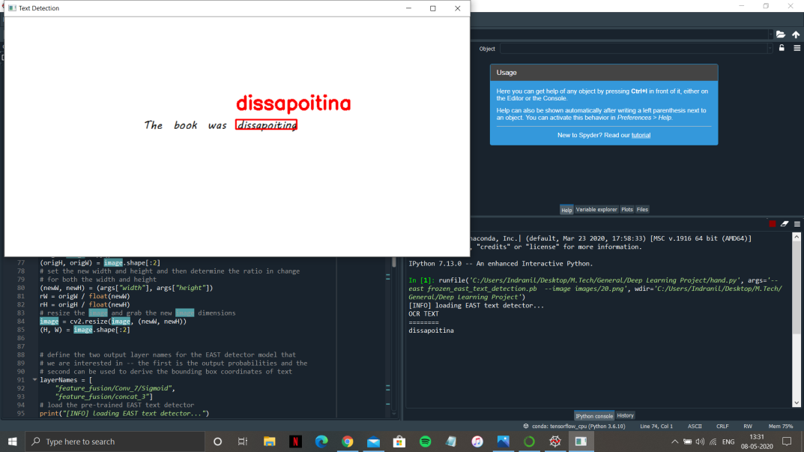

Figure 3

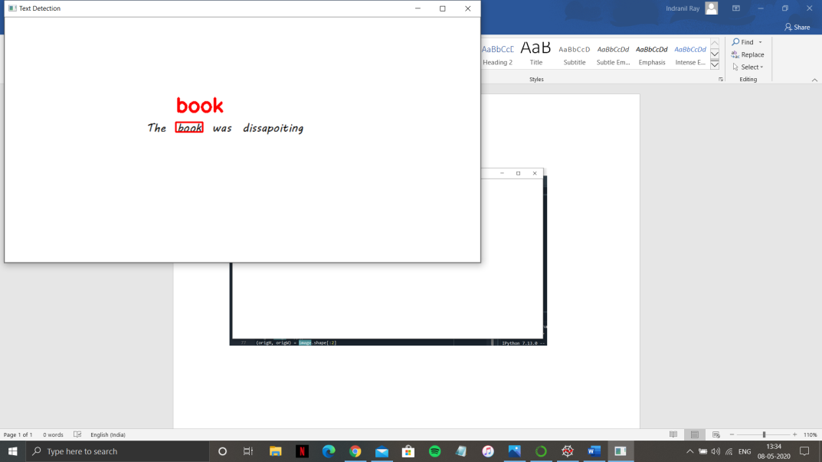

Figure 4

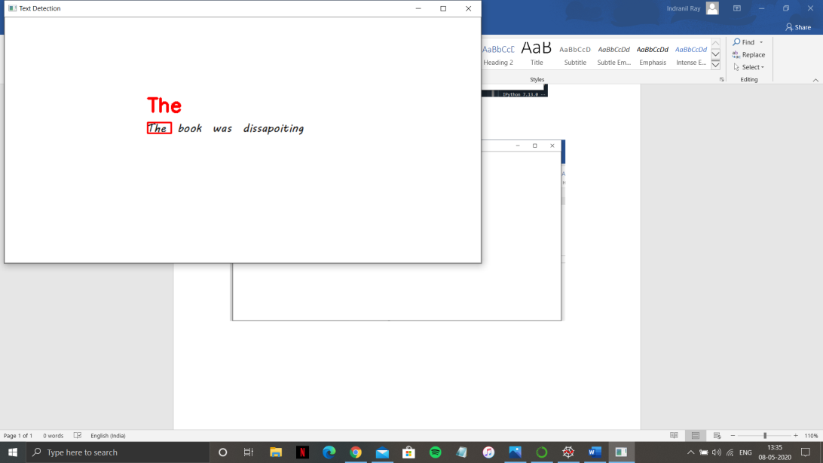

Figure 5

*Figure 6 represents the process of loading the EAST text detector*.

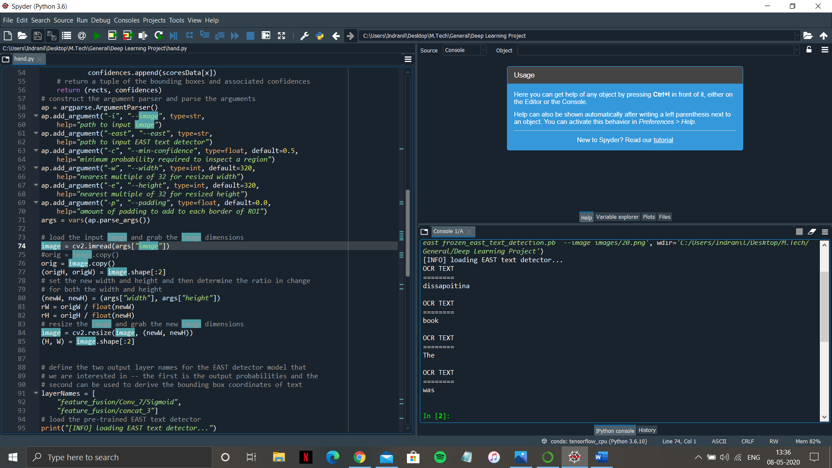

Figure 6

Results of NLP and Naive Bayes Classifier:

*Figure7 shows the sentiment distribution count.* We have segregated them as positive and negative reviews.

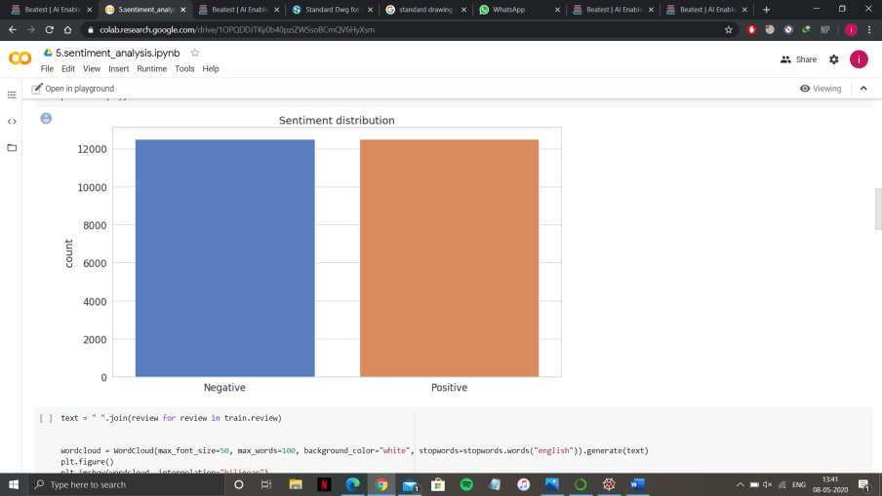

Figure 7

*Figure 8 shows the accuracy of our model*, which turns out to be nearly 86%.

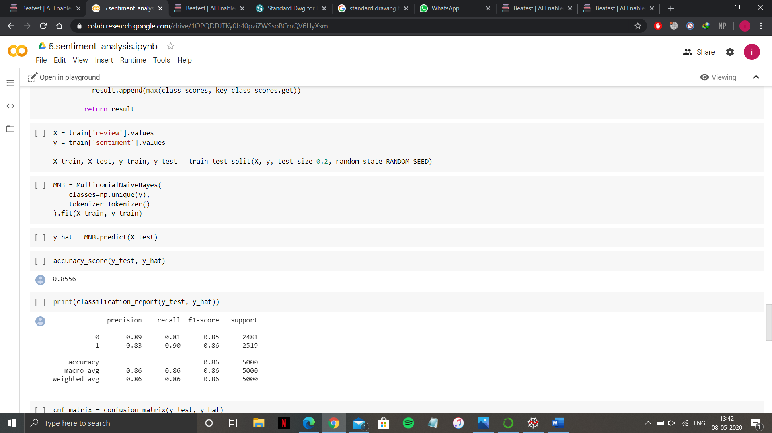

Figure 8

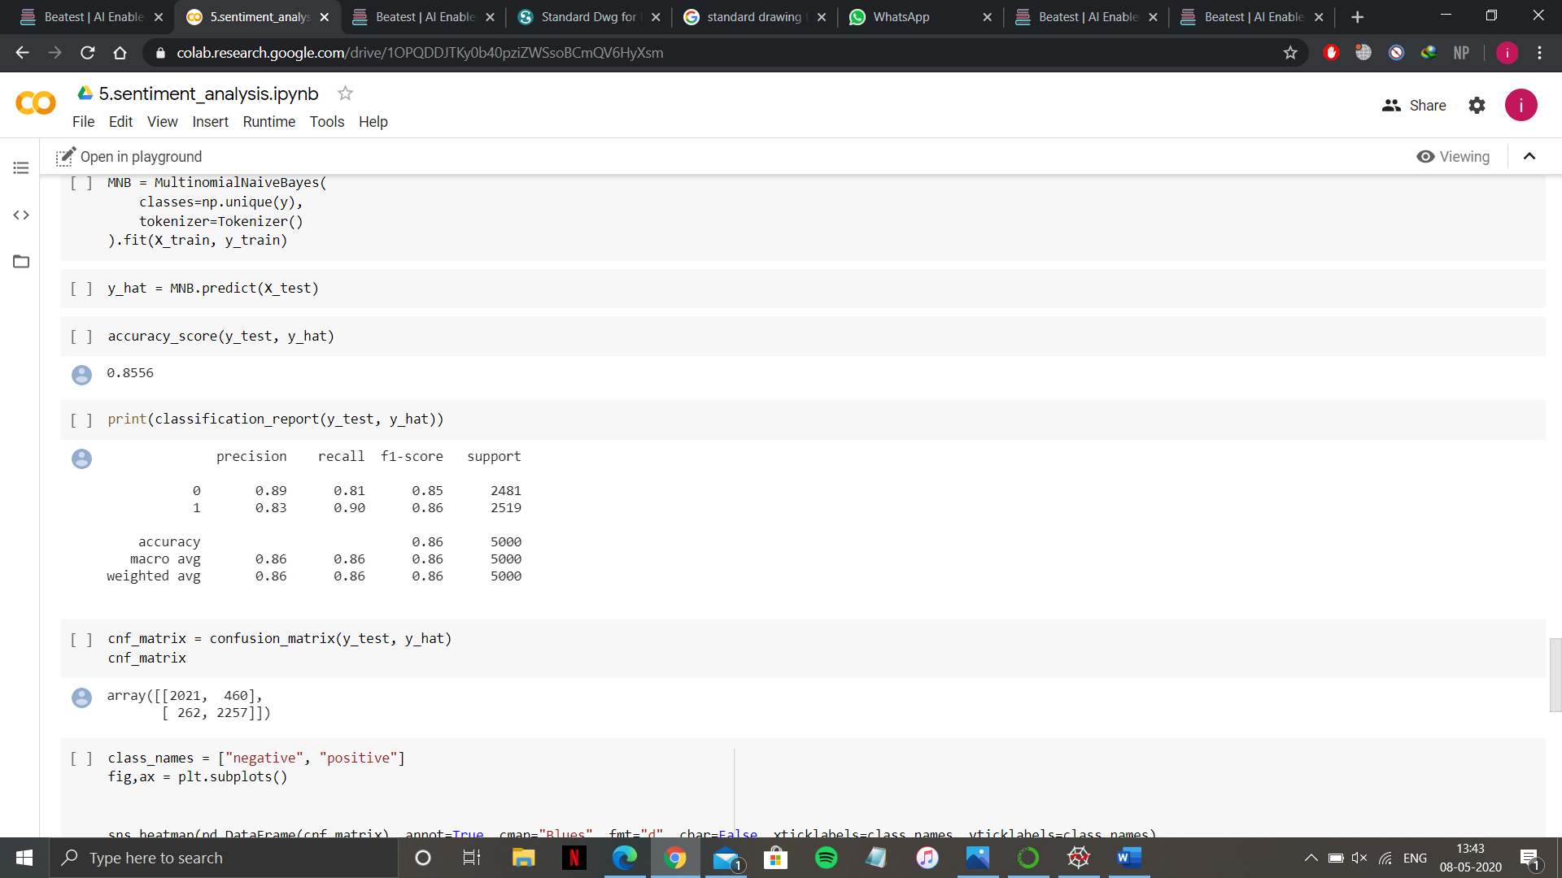

Figure 9

*In Figure 9, we can see the classification report of our model*. In the next figure, i.e., *Figure 10 and 11, the confusion matrix of our model is represented*.

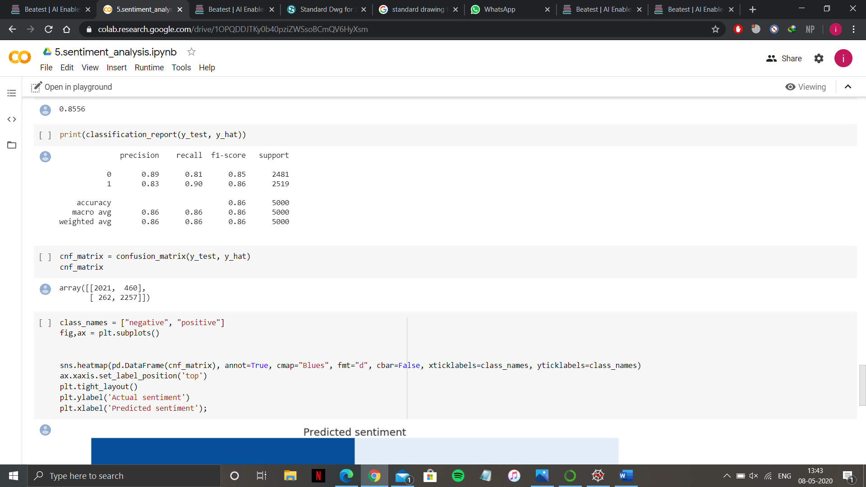

Figure 10

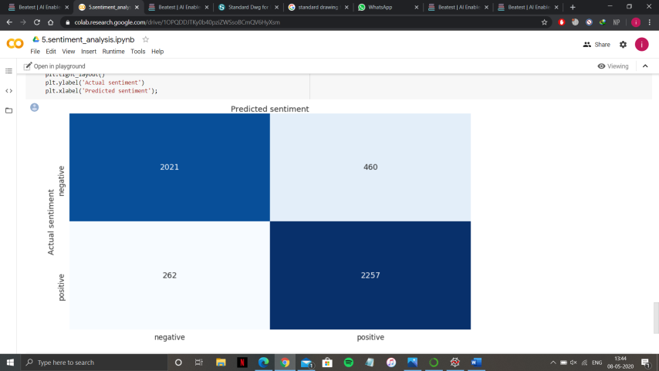

Figure 11

**Future Works:**

There is a lot of promising areas where this project can be extended. While doing the literature survey for this project, we naturally came across brilliant ideas such as those presented in [4],[11], [15], [16], [17] and [19]. One crucial challenge for the coming decade is to be able to harvest relevant information from the constant flow of multimodal data from social media websites [20]. In addition to that, some of the papers such as [10], [13], [14] has mentioned using Recurrent Neural Networks. Certainly, one work that naturally comes to mind is that a comparative study about the accuracy among the several sentiment analysis techniques or models represented in those papers. Further, this work can also be extended to predict not only the sentiment of the text but also the emotional status of the writer at the exact point of writing the text.

**REFERENCES:**

[1] The Tesseract open source OCR engine, http://code.google.com/p/tesseract-ocr.

[2] “Optical Character Recognition”, RavinaMithe, SupriyaIndalkar, NilamDivekar, International Journal of Recent Technology and Engineering (IJRTE), ISSN: 2277-3878, Volume-2, Issue-1, March 2013.

[3] https://www.researchgate.net/figure/Block-diagram-of-a-typical-OCR-System_fig1_289675117

[4] “Sentiment Analysis Based Mining and Summarizing Using SVM-MapReduce”, JayashriKhairnar, MayuraKinikar, Department of Computer Engineering, Pune University, MIT Academy of Engineering, Pune, International Journal of Computer Science and Network Security (IJCSNS), Vol 15, No 5, May 2015.

[5] “A Novel, Gradient Boosting Framework for Sentiment Analysis in Languages where NLP Resources are not Plentiful: A Case Study for Modern Greek”, Vasileios Athanasiou, ManolisMaragoudakis, Artificial Intelligence Laboratory, University of the Aegean, 12th IFIP WG 12.5 International Conference and Workshops. AIAI 2016, Thessaloniki, Greece, 16-18 September 2016.

[6] “A Survey of Opinion Mining and Sentiment Analysis”, Bing Liu, Lei Zhang, University of Illinois at Chicago, IL

[7] “A Survey on Sentiment Analysis and Summarization for Prediction”, Vikrant Hole, Mukta Takalikar, Department of Computer Engineering, Pune, India, International Journal of Engineering and Computer Science (IJECS) ISSN: 2319-7242, Volume 3 Issue 12 December 2014, Page NO 9503-9506

[8] “An Overview of Feature Extraction Techniques in OCR for Indian Scripts Focused on Offline Handwriting”, Gaurav Y. Tawde, Mrs. Jayashree M. Kundargi, International Journal of Engineering Research and Applications (IJERA) ISSN: 2248-9622 Volume 3 Issue 1 January-February 2013, pp. 919-926

[9] “An Overview of Handwriting Recognition”, Homayoon S.M. Beigi, T.J. Watson Research Center, International Business Machines.

[10] “Contextual Bidirectional Long Short-term Memory Recurrent Neural Network Language Models: A Generative Approach to Sentiment Analysis” Amr El-Desoky Mousa, Chair of Complex & Intelligent Systems, University of Passau, Passau, Germany and Bjorn Schuller, Department of Computing, Imperial College London, London, UK.

[11] “Handwriting Analysis based on Segmentation Method for Prediction of Human Personality using Support Vector Machine”, International Journal of Computer Applications (0975-8887) Volume 8 No 12, October 2010, Shitala Prasad, Vivek Kumar Singh, AkshaySapre, Department of Information Technology, Indian Institute of Information Technology, Allahabad, India

[12] “Handwritten Character Recognition using Neural Network”, International Journal of Scientific & Engineering Research Volume 2, Issue 5, May-2011, ISSN 2229-5518, Chirag I Patel, Ripal Patel, Palak Patel.

[13] Andrew William Senior, Trinity Hall, Cambridge, England, September 1994, “Off-line Cursive Handwriting Recognition using Recurrent Neural Networks”.

[14] Saqib Alam, Nianmin Yao, School of Electrical Information and Electrical Engineering, Dalian University of Technology, Liaoning, Dalian 116024, “Probabilistic Neural Network and Word Embedding for Sentiment Analysis”, International Journal of Advanced Computer Science and Applications, Volume 9 Issue 7, 2018.

[15] Shamim Biswas, Ekamber Chadda, Faiyaz Ahmad, Department of Computer Engineering, Jamia Milia Islamia, New Delhi, India, “Sentiment Analysis with Gated Recurrent Units”, Advances in Computer Science and Information Technology (ACSIT), ISSN: 2393-9907(Print), 2393-9915(Online), Volume 2, Issue 11, April-June, 2015, pp. 59-63.

[16] “Sentiment Analysis of Customer Reviews based on Hidden Markov Model”, Swati Soni, AakankshaSharaff, Department of Computer Science and Engineering, NIT Raipur, Raipur, India.

[17] “Sentiment Analysis of Online Reviews using Bag-of-Words and LSTM Approaches”, James Barry, School of Computing, Dublin City University, Ireland.

[18] “Sentiment Analysis on Bangla and Romanized Bangla Text (BRBT) using Deep Recurrent Models”, Asif Hassan, Mohammad Rashedul Amin, Abul Kalam Al Azad, Nabeel Mohammed, Dept. of Computer Science and Engineering, University of Liberal Arts (ULAB), Dhaka, Bangladesh.

[19] “Towards Multimodal Sentiment Analysis: Harvesting Opinions from the Web”, Louis-Philippe Morency, Institute for Creative Technologies, University of Southern California, LA, CA 90094 and Rada Mihalcea, University of North Texas, Denton, TX 76203.

[20] “Using an Emotion-based Model and Sentiment Analysis Techniques to Classify Polarity for Reputation”, Jorge Carrillo de Albornoz, Irina Chugur, Enrique Amigo, Natural Language Processing and Information Retrieval Group, UNED Juan del Rosal, 16 (Ciudad Universitaria), 28040 Madrid, Spain.

[21] “An Overview of the Tesseract OCR Engine”, Ray Smith, Google Inc.

[22] https://medium.com/@jaafarbenabderrazak.info/opencv-east-model-and-tesseract-for-detection-and-recognition-of-text-in-natural-scene-1fa48335c4d1